Congratulations to the Cast of High School Musical!

***Please initial next to your name to accept the role by Monday, 1/16 ***

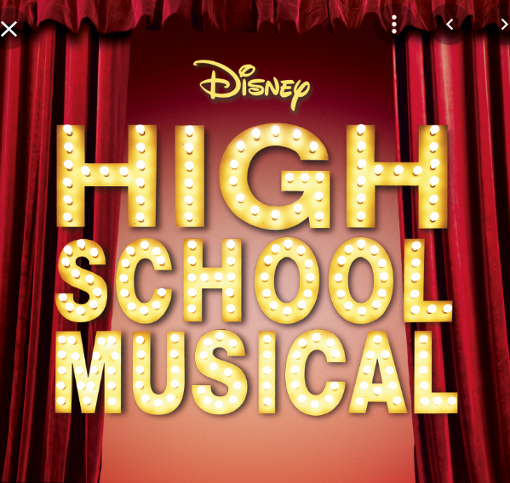

(In Order of Appearance)

Jack Scott..….…………………..……………Yotam Ginsburg-Levin
Cher Danforth...………….……………………...……...Becca Clarke
Zeke Baylor…………………………….….……………...…..Lee Win
Troy Bolton...…………………………….….………….…Ceci Clarke
Sharpay Evans……………………………………...Katie McGhinnis
Regan Evans…………..………………………….…Finley Roessler
Gabriella Montez.……………………………….……...Olivia Corliss
Taylor McKenzie…………………………….…….…...Isabel Sutton
Kelsi Nielson…..………...…………………………Grace Kovalesky
Martha Cox……………………………………..….…Claire Arbuckle
Ms. Darbus………………………………………………Olivia Sutton
Coach Jane Bolton…….…………………………….…Mo Edenfield
Ms Tenny.………..…………………………..….…Tierney Schmidt
Kratnoff……...…………………………………..Cameron Langston
Cathy………………………………..……Siena Maxwell-Crumbliss
Cyndra……………………………………………..Ananya Hiremath
Jamie……………………………………………..…..Addison Curtis
Susan……………………………………………..Carmen Tarajano
Moderator……………………………………..Caitlyn Formy-Duval
Natalie……………………………………………………....Isa Hood
Ariana…………………………………………………..…Sadie Sole
Mindi…………………………………………...…..Lourdes Manson
Paige……………………………………………...…..Charlie Aitken
Miranda…………………………………………..Natasha Dolinsky
Jordan……………….……………………………..Caroline McGee
Brandy……………….………………………….…..Meara McCabe
Jess...………………….…………………………..…..Waverly Pike
Eloise………………….…………………….………Parker Dodson
Rachel………………….……………………………..…Reni Fuller

Get’cha Head in the Games Dancers:
Ceci Clarke, Andro Hayward, Ronke Ologbenla, Charlie Aitken, Holden Somers, Natasha Dolinski, Kailyn Burgen, Naomi Kells

ALL PERFORMERS: Please note which “clique” you’re in

The Cliques:
Cheerleaders: Isa Hood, Bella Becton, Sadie Sole & Caroline McGee

Jocks: Mo Edenfield, Ceci Clarke, Becca Clarke, Lee Win, Charlie Aitken, Natasha Dolinsky, Andro Hayward, Kailyn Burgin, Naomi Kells, Holden Somers, Teagan Mallen, Ronke Ologbenla

Brainiacs: Tierney Schmidt, Caitlyn Formy-Duval, Olivia Corliss, Isabel Sutton, Claire Arbuckle, Cameron Langston, Yotam Ginsburg-Levin, Lourdes Manson, Waverly Pike, Abigail Vaughn, Skye Poovey

Thespians: Olivia Sutton, Katie McGhinnis, Finley Roessler, Grace Kovalesky, Siena Maxwell-Crumbliss, Ananya Hiremath, Addison Curtis, Carmen Tarajano, Meara McCabe, Reni Fuller, Parker Dodson

